27. Write Java methods to calculate triangle area.

Expected Output:

Input Side-1: 10

Input Side-2: 15

Input Side-3: 20

The area of the triangle is 72.6184377413890

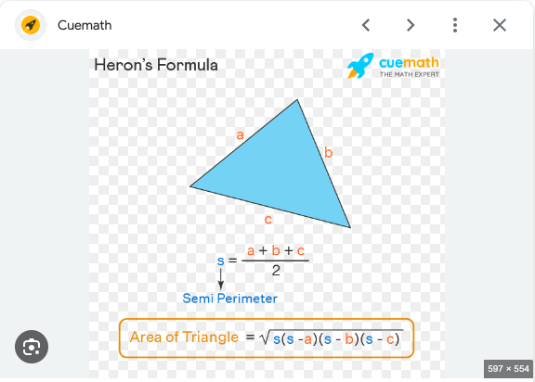

import java.util.Scanner;

public class Exercise27 {

public static void main(String[] args) {

Scanner scanner = new Scanner(System.in);

System.out.print("Input Side-1: ");

double side1 = scanner.nextDouble();

System.out.print("Input Side-2: ");

double side2 = scanner.nextDouble();

System.out.print("Input Side-3: ");

double side3 = scanner.nextDouble();

double area = calculateTriangleArea(side1, side2, side3);

System.out.println("The area of the triangle is " + area);

scanner.close();

}

public static double calculateTriangleArea(double side1, double side2, double side3) {

// Heron's formula to calculate the area of a triangle

double s = (side1 + side2 + side3) / 2;

double area = Math.sqrt(s \* (s - side1) \* (s - side2) \* (s - side3));

return area;

}

}